**6) An Intelligent Go-Player using an Alpha-Beta Depth-First algorithm (designing & implementing at least 2 heuristic**

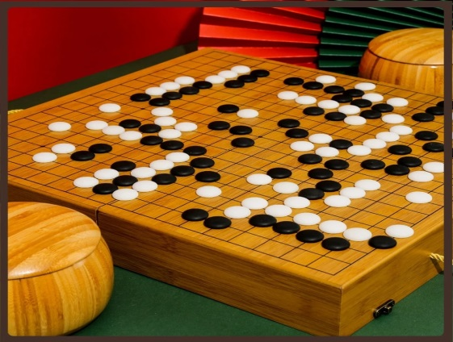

**(1) Project ideas in details**

Go ("weiqi" in Chinese, "baduk" in Korean), is an ancient board game for two players that originated in China over 2,000 years ago. The game is noted for being rich in strategy despite its relatively simple rules (see Rules of Go).

The game is played by two players who alternately place black and white stones on the vacant intersections (called "points") of a grid of 19×19 lines (beginners often play on smaller 9×9 and 13×13 boards). Stones act as markers, representing one's occupation of a particular point. The object of the game is to use one's stones to surround a larger portion of the board than the opponent. Once placed on the board, stones cannot be moved, though they can be removed if they are captured. When a game concludes, the controlled points (territory) are counted along with captured stones to determine who has more points. Games may also be won by resignation.

Go is one of the most important strategy games in the world, with federations and professional players that practice it for a living, just like chess.  The prizes of the major tournaments may reach half a million dollars or more. Nevertheless, there is not one Go federation in the Arab world.   
Go differs from chess rules by having easier rules but harder application. Where as today's computer can even compete with the strongest champions of chess, it is easily defeated by average amateur players.

Go is considered to be a metaphor for life and its struggles. It makes the player see life in a deeper and more holistic manner. Top general managers and army generals have benefited greatly from the game. It exercises and polishes the mind of individuals and even that of children. Practising this game will have a positive effect on your life.

**(2) Main functionalities:-**

### **Equipment and Aim**

Go pieces are black and white lens-shaped discs called stones. The Go board can either be a flat table board or the more traditional floor-board with legs (Go-ban). Either way, the board is simply a grid of 19 x 19 lines, the stones being placed upon the intersections of the lines. For shorter games and for beginners, 13 x 13 and 9 x 9 boards are commonly used.  
Go is a game of territorial capture - the primary objective is to encircle as much territory as possible. In doing so, opposing stones may be captured and the winner is the player at the end with the greatest amount of territory and captured stones.

### **Basic Definitions**

The most essential terms to understand are “group" and "liberty".  
A group of stones is any set of stones of the same colour that are connected orthogonally (horizontally or vertically). So three stones in a row along a line forms a group because every stone sits orthogonally next to at least one other stone. However 2 stones next to each other diagonally are not connected in any way and so simply form two groups of one stone each. If a third stone were to be added to the two diagonal stones so that it sat next to both of them, a group of three stones would be formed. Groups can get quite large and convoluted but the principle remains the same - if a stone lies orthogonally next to another stone then both stones are part of the same group.  
  
Any empty point orthogonally adjacent to a group of stones is said to be a liberty of that group. A single stone by itself in the middle of the board therefore has 4 liberties, 1 in each of the 4 directions. A group of 3 stones by itself in a line on the edge of the board has 5 liberties - 1 at either end and 3 towards the middle of the board. A single stone in the corner of the board has just 2 liberties. And a group of 8 stones set in a square by itself has 13 liberties - 12 around the outside and 1 in the middle.  
  
Each stone laid by the opponent next to a group reduces the number of liberties by 1. So a single stone with opposing stones North, South and East of it has only 1 liberty.

### **The Rules of Go**

Go is not only pleasing to the eye, the game itself is also beautifully aesthetic in its simplicity. In essence there are really only 3 rules to the game:

* Starting with black, each player takes turns to place a single stone on the board.
* When a stone is played so that it causes a group of opposing stones to have no liberties, that group is captured.
* A player cannot play a stone to a location such that a previous position is repeated.  
  So a single stone is captured if the opponent places four stones on the four orthogonal points surrounding it. And a group of 2 stones on the edge of the board is captured by 4 enemy stones.

### **Eyes - the key to Go**

An important point to realise is that a group of 8 stones set in a square is difficult to capture because if the opponent places a stone in the middle of the group, under most circumstances, that stone is immediately captured by the surrounding group. Consequently, no player would ever normally make such a play.  
  
The unoccupied point in the middle of the group is an example of an "eye". An eye is any empty point that is surrounded orthogonally by pieces of the same colour - always difficult for an opponent to capture. However, eyes are not impossible to take - the group of 8 stones can be captured by an opponent who first occupies the 12 surrounding points. After this, the group of 8 stones is vulnerable - if the player who owns it plays to the middle of the group, the group of 9 stones would be immediately captured having no remaining liberties. And this is the only situation where it is legitimate for the opponent to play a stone to the middle since in doing so, the last remaining liberty of the group is eliminated and the group is captured. The stone just played would be left surrounded by 4 liberties.  
  
Derived from this is the key factor in Go defence - any group containing two eyes is safe and can never be captured. This should be easy to understand after a moments thought - in order to capture the group all liberties must be eliminated and so both eyes would need to be occupied. But since a stone played to either eye would immediately be captured, it is impossible for both eyes to be occupied. QED.  
  
In conclusion, eyes are useful and a group with 2 eyes is invulnerable.

### **Other terms**

"Ko" is a local situation in which a position can be repeated indefinitely. Normally, this is a simple situation where one player can take a stone and the other player can then play a stone back to where his stone has just been captured and take the first player's stone back again. Note that due to the third rule above, a player cannot immediately play a stone to put a position back to how it was. At least one stone must be played elsewhere before a player can reverse a Ko situation otherwise the a previous overall position of the board would be repeated.  
  
"Seki" is another local situation. This term applies to an area into which neither player dare play because to do so would cause the opponent to capture territory or stones.  
  
To have "Sente" is to be in a position to make a move that will force the opponent to take a counter-action. If a player with sente makes the play in question and the opponent, instead of responding in the predicted way, makes a different play with an even greater threat, the opponent is said to have "assumed Sente".  
  
Any group of stones that is under threat of imminent capture i.e. having only one liberty left is said to be in "Atari".  
  
A "dame" point is an empty point between territories. When there is a dame point there is no benefit to either player. Dame points are left alone until the end of the game and then ignored in scoring.

### **Starting**

Go employs a simple and effective handicapping scheme. The weaker player always plays black but also places an amount of stones onto the board before the start of the game according to the amount of the handicap. The board has nine highlighted intersections in a square shape marked on the board called "star" points. The requisite number of stones are placed the star points in the following way:

* 1 stone handicap - on a corner star point
* 2 stone handicap - on opposite corner star points
* 3 and 4 stone handicap - on 3 or 4 corner star points
* 5 stone handicap - 4 corner + 1 side star point
* 6 stone handicap - 4 corner + 2 opposing side star points
* 7 and 8 stone handicap - 4 corners + 3 or 4 side star points
* 9 stone handicap - all 9 star points.

Beginning the game in Go is both critical and very difficult to do well. Players try to play stones far enough apart so that they form the beginnings of territory encirclements but close enough so that they can be linked up into groups should they come under attack. Initial stones tend to be played near the corners - corners are the easiest places to capture territory because they only have to be surrounded on two sides. Good players will begin by positioning stones seemingly at random across the board but in reality they are staking their claims to particular areas. After this initial period, local skirmishes and larger battles will form in areas of contention. Players need to be able to comprehend and deal with all the smaller conflicts while never becoming distracted from the overall picture of the war.

### **Finishing**

Eventually, the players agree that no more stones can be played since all territory is claimed and all local battles have been played to their conclusion. Play continues until both players agree to this. At this point the winner and the margin of victory is determined.  
  
This is done in summary by comparing the sum of number of points of territory plus the number of prisoners captured. The totals are unimportant - it is the difference between them that is measured and it is customary to work this out in by following the following process which makes the counting much easier:

* First, any Dame points are filled – players continue to take turns playing their stones into these neutral areas until they are all filled. These are usually considered to be the final moves of the game - the game is only finished once all Dame points are filled.
* Any dead stones (stones within the opponent’s territory) are treated as prisoners and therefore they are now removed from the board into the pile of stones captured by each player.
* To simplify counting, next each black prisoner is placed back on the board in black territory and white prisoners are placed within white territory. The logic is simple – each prisoner counts 1 point so by placing on the board this point is lost but that is compensated for by the fact that the opponent loses a point of territory. Overall the difference remains the same.
* To further facilitate the counting process, stones on the board are now moved around so that the territories form neater patterns. In doing this, players simply take care not to change the amounts of territory owned. So each black stone moved exposes a point of territory but another black territory point is covered to compensate. Where possible, territories are manipulated into rectangular shapes and often larger territories are reformed into areas that are multiples of ten.
* Once the board and prisoners have been consolidated in this fashion, the winner and the margin of victory can be quickly determined by a count of the simplified territories.

Since it is generally recognised that black has a slight advantage by going first, non-handicapped games are often decided as the best of two games with players taking turns to play black. The margins of victory are summed after both games have been completed to determine the winner.  
  
An alternative method of dealing with this imbalance developed in modern times is to award white 6.5 extra points each game.

**Use Case Diagram:**

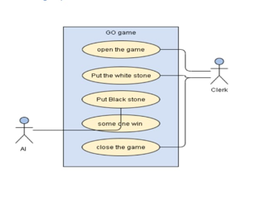

**(3) Similar applications in the market :-**

**Google play:**

[**https://play.google.com/store/apps/details?id=uk.co.aifactory.gofree**](https://play.google.com/store/apps/details?id=uk.co.aifactory.gofree)

**App store :**

[**https://apps.apple.com/app/id1500161327**](https://apps.apple.com/app/id1500161327)

**(4) An initial literature review of Academic publications:-**

**Go** is an abstract strategy board game for two players in which the aim is to surround more territory than the opponent. The game was invented in China more than 2,500 years ago and is believed to be the oldest board game continuously played to the present day.

The playing pieces are called stones. One player uses the white stones and the other, black. The players take turns placing the stones on the vacant intersections (*points*) of a board. Once placed on the board, stones may not be moved, but stones are removed from the board if the stone (or group of stones) is surrounded by opposing stones on all orthogonally adjacent points, in which case the stone or group is *captured*. The game proceeds until neither player wishes to make another move. When a game concludes, the winner is determined by counting each player's surrounded territory along with captured stones and komi (points added to the score of the player with the white stones as compensation for playing second). Games may also be terminated by resignation.

The standard Go board has a 19×19 grid of lines, containing 361 points. Beginners often play on smaller 9×9 and 13×13 boards, and archaeological evidence shows that the game was played in earlier centuries on a board with a 17×17 grid. However, boards with a 19×19 grid had become standard by the time the game reached Korea in the 5th century CE and Japan in the 7th century CE.

Go was considered one of the four essential arts of the cultured aristocratic Chinese scholars in antiquity. The earliest written reference to the game is generally recognized as the historical annal *Zuo Zhuan* (c. 4th century BCE).

The origins of go are shrouded in the mists of ancient Chinese history, but the game is thought to have originated at least 2500 - 4000 years ago. It is the oldest game still played in its original form.

Some say that the board, with ten points out from the center in all directions, may have originally served as a forerunner to the abacus. Others think it may have been a fortune-telling device, with black and white stones representing yin and yang. A prominent legend holds that the sage-king Yao created the game to teach his rebellious son discipline.

By 400-300 B.C., Chinese scholars such as Confucius were writing about wei-chi (a Chinese name for the game) to illustrate correct thinking about filial piety and human nature. By the 1600's it had become one of the "Four Accomplishments" (along with calligraphy, painting, and playing the lute) that must be mastered by the Chinese gentleman. This kind of sanctified thinking about the game has inspired people to play for millennia.

Wei-chi, also written as wei-ch'i or weiqi, entered Korean and Japanese culture through trade and other contact between countries in the first millennium A.D. In ancient Chinese art, noblemen (and noblewomen!) can occasionally be found playing go.

**Origin in China**

The earliest written reference to the game is generally recognized as the historical annal *Zuo Zhuan* (c. 4th century BCE), referring to a historical event of 548 BCE. It is also mentioned in Book XVII of the *Analects of Confucius* and in two books written by Mencius (c. 3rd century BCE).  In all of these works, the game is referred to as *yì* (弈). Today, in China, it is known as ***weiqi*** (simplified Chinese: 围棋; traditional Chinese: 圍棋; pinyin: *wéiqí*; Wade–Giles: *wei ch'i*), lit. 'encirclement board game'.

Go was originally played on a 17×17 line grid, but a 19×19 grid became standard by the time of the Tang Dynasty (618–907 CE). Legends trace the origin of the game to the mythical Chinese emperor Yao (2337–2258 BCE), who was said to have had his counselor Shun design it for his unruly son, Danzhu, to favorably influence him. Other theories suggest that the game was derived from Chinese tribal warlords and generals, who used pieces of stone to map out attacking positions.

In China, Go was considered one of the four cultivated arts of the Chinese scholar gentleman, along with calligraphy, painting and playing the musical instrument guqin In ancient times the rules of go were passed on verbally, rather than being written down.

### Spread to Korea and Japan

Go was introduced to Korea sometime between the 5th and 7th centuries CE, and was popular among the higher classes. In Korea, the game is called ***baduk*** (hangul: 바둑), and a variant of the game called Sunjang baduk was developed by the 16th century. Sunjang baduk became the main variant played in Korea until the end of the 19th century, when the current version was reintroduced from Japan.

The game reached Japan in the 7th century CE—where it is called ***go*** (碁) or ***igo*** (囲碁). It became popular at the Japanese imperial court in the 8th century, and among the general public by the 13th century. The game was further formalized in the 15th century. In 1603, Tokugawa Ieyasu re-established Japan's unified national government. In the same year, he assigned the then-best player in Japan, a Buddhist monk named Nikkai (né Kanō Yosaburo, 1559), to the post of Godokoro (Minister of Go).

Nikkai took the name Hon'inbō Sansa and founded the Hon'inbō Go school. Several competing schools were founded soon after. These officially recognized and subsidized Go schools greatly developed the level of play and introduced the dan/kyu style system of ranking players. Players from the four schools (Hon'inbō, Yasui, Inoue and Hayashi) competed in the annual castle games, played in the presence of the shōgun.

### In Azerbaijan

The game is also historically played in Azerbaijan, known there as **galagapy** (Azerbaijani: *qalaqapı*, lit. 'castle-gate'), or **kishmish oyunu** (Azerbaijani: *kişmiş oyunu*, lit. 'raisin game'). The Azerbaijani version is played with black and white raisins rather than black and white stones. The game begins with the player holding the black pieces. As a result, the black pieces on the game board are placed towards the player's heart as a symbol of closeness to the heart and sincerity. Giving a few black pieces to the player with white pieces beforehand balances the players.

In the Azerbaijani version, the stronger side gives *dədəboyu* (lit. 'chance') to the weaker one. Up to 9 black pieces can be arranged on the *dədəboyu* intersections. The moves are called *dov* (lit. 'to overcome'), meaning that the players take turns to attack each other and increase their strength. When a player makes forbidden moves, the other player says *kov deyil* (lit. 'it is not counted') and offers to put the piece in another intersection. Repetition of any situation that occurred in the game is also subject to the rule *kov deyil*.

**Japan's Four Go Schools**

We know that go was present in Japan at least since 1000 A.D., since it figures peripherally in Murasaki's The Tale of Genji, but it took a giant leap forward there in the 1600s. When the warlord Tokugawa unified Japan in 1602, he decreed that four schools of go would be established.

Each year representatives of the schools would play in a "Castle Game" series, and the winner would hold the Cabinet-level position of go-doroko (Minister of Go) for the following year. This system raised go to a new level of skill and popularity.

With the Meiji restoration in the late 1800s, go fell into a period of relative decline in Japan, but it was brought back to life in the 1920s with the formation of the Japan Go Association. Newspapers began to sponsor tournaments, a professional system was established, and today there are more than a dozen major titles, with columns and game analysis every day in the major newspapers. Top Japanese go players are major celebrities.

### Internationalization

Despite its widespread popularity in East Asia, Go has been slow to spread to the rest of the world. Although there are some mentions of the game in western literature from the 16th century forward, Go did not start to become popular in the West until the end of the 19th century, when German scientist Oskar Korschelt wrote a treatise on the game. By the early 20th century, Go had spread throughout the German and Austro-Hungarian empires. In 1905, Edward Lasker learned the game while in Berlin. When he moved to New York, Lasker founded the New York Go Club together with (amongst others) Arthur Smith, who had learned of the game in Japan while touring the East and had published the book *The Game of Go* in 1908. Lasker's book *Go and Go-moku* (1934) helped spread the game throughout the U.S., and in 1935, the American Go Association was formed. Two years later, in 1937, the German Go Association was founded.

World War II put a stop to most Go activity, since it was a popular game in Japan, but after the war, Go continued to spread. For most of the 20th century, the Japan Go Association (Nihon Ki-in) played a leading role in spreading Go outside East Asia by publishing the English-language magazine *Go Review* in the 1960s, establishing Go centers in the U.S., Europe and South America, and often sending professional teachers on tour to Western nations. Internationally, the game had been commonly known since the start of the twentieth century by its shortened Japanese name, and terms for common Go concepts are derived from their Japanese pronunciation.

In 1996, NASA astronaut Daniel Barry and Japanese astronaut Koichi Wakata became the first people to play Go in space. They used a special Go set, which was named Go Space, designed by Wai-Cheung Willson Chow. Both astronauts were awarded honorary dan ranks by the Nihon Ki-in.

As of December 2015, the International Go Federation has 75 member countries, with 67 member countries outside East Asia. Chinese cultural centres across the world are promoting Go, and cooperating with local Go associations, for example the seminars held by the Chinese cultural centre in Tel Aviv, Israel, together with the Israeli Go association.

**(6) Details of the algorithm(s)/approach(es) that will be used :**

## We used an minimax algorithm and dipth first search algorithm n

## Mini-Max Algorithm

* In AI, the Min-Max algorithm is mostly employed for game play. Chess, checkers, tic-tac-toe, go, and other two-player games are examples. This Algorithm calculates the current state's minimax choice.
* The game is played by two players, one named MAX and the other named MIN, in this algorithm.
* Both players FIGHT it, since the opponent player receives the smallest benefit while they receive the greatest profit.
* Both players in the game are adversaries, with MAX selecting the maximum value and MIN selecting the minimum value.
* For the exploration of the entire game tree, the minimax method uses a depth-first search strategy.
* For the exploration of the entire game tree, the minimax method uses a depth-first search strategy.
* The minimax algorithm descends all the way to the tree's terminal node, then recursively backtracks the tree.

## **Limitation of the minimax Algorithm:**

The biggest disadvantage of the minimax algorithm is that it becomes extremely slow while playing complex games like chess or go. This style of game contains a lot of branching, and the player has a lot of options to choose from. The minimax algorithm's drawback can be alleviated by using **alpha-beta pruning** , which we will explore in the next section. the depth to which the tree can grow.

Best way of learing.

# Alpha-Beta Pruning

* Alpha-beta pruning is a modified version of the minimax algorithm. It is an optimization technique for the minimax algorithm.
* As we have seen in the minimax search algorithm that the number of game states it has to examine are exponential in depth of the tree. Since we cannot eliminate the exponent, but we can cut it to half. Hence there is a technique by which without checking each node of the game tree we can compute the correct minimax decision, and this technique is called **pruning**. This involves two threshold parameter Alpha and beta for future expansion, so it is called **alpha-beta pruning**. It is also called as **Alpha-Beta Algorithm**.
* Alpha-beta pruning can be applied at any depth of a tree, and sometimes it not only prune the tree leaves but also entire sub-tree.
* The two-parameter can be defined as:
  1. **Alpha:** The best (highest-value) choice we have found so far at any point along the path of Maximizer. The initial value of alpha is **-∞**.
  2. **Beta:** The best (lowest-value) choice we have found so far at any point along the path of Minimizer. The initial value of beta is **+∞**.
* The Alpha-beta pruning to a standard minimax algorithm returns the same move as the standard algorithm does, but it removes all the nodes which are not really affecting the final decision but making algorithm slow. Hence by pruning these nodes, it makes the algorithm fast.

In our project we used two heuristic function

1.heuristic 1: here we call the max function

That the agent try to maxmize it’s winnig

2.heuristic 2: and here we call the min function

That the agent try to minimize it’s loss

**Experiments & Result**

In first experiment we use huristic function min_value() that try to minimize its loss as shown in image:

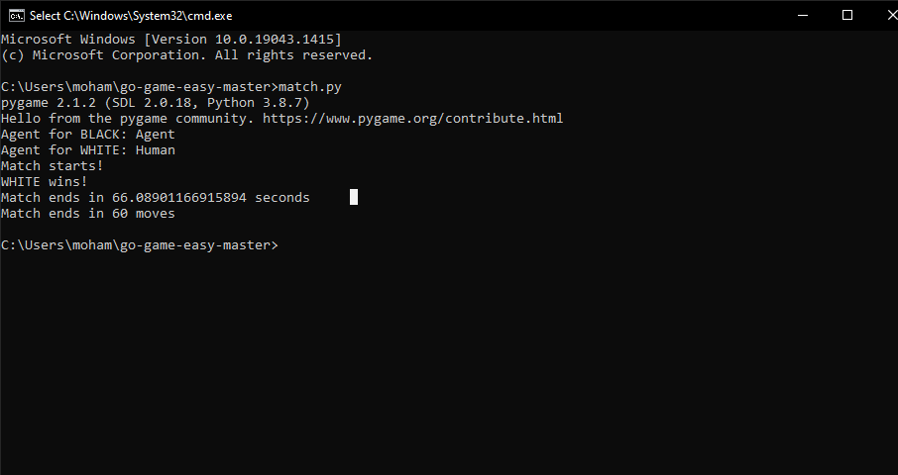

And in second experiment we use huristic function max_value() that try to beat human aggressively as shown in image:

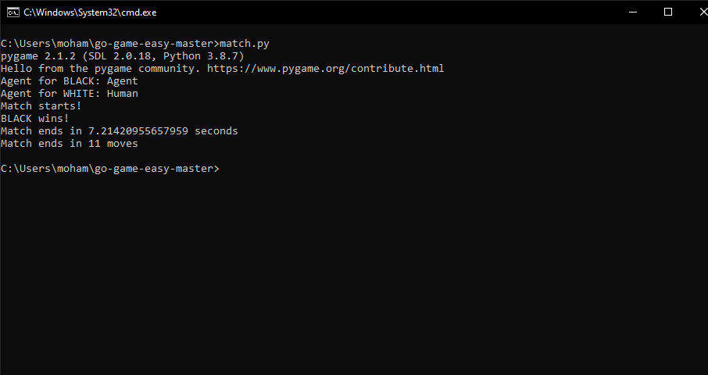

so max_value can finish match in 7.21 seconds with only 11 moves.

Analysis, Discussion, and Future

- Analysis of the results, what are the insights?

2 huristic function do good work and we can call The Agent is very smart

In Go Game

- Why did the algorithm behave in such a way? What might be the future modifications you’d like to try when solving this problem?

-- Players Can use any Places be more free in choose place in game

-- find Another Huristic function that made Agent undefeatable

67

Block diagram for game:

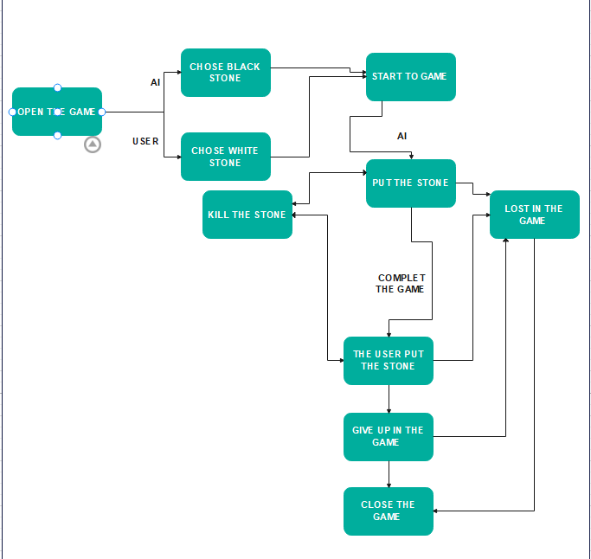

Block diagram for system:

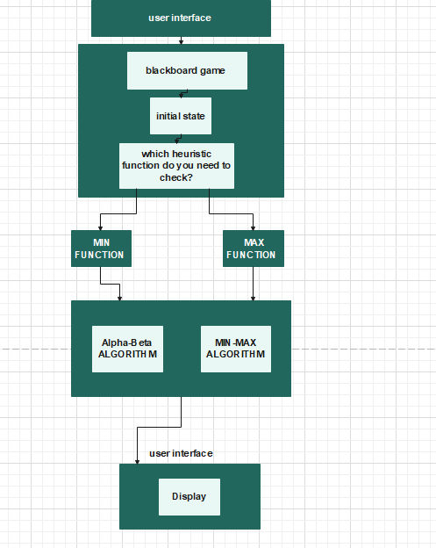:

Flow chart for algorithm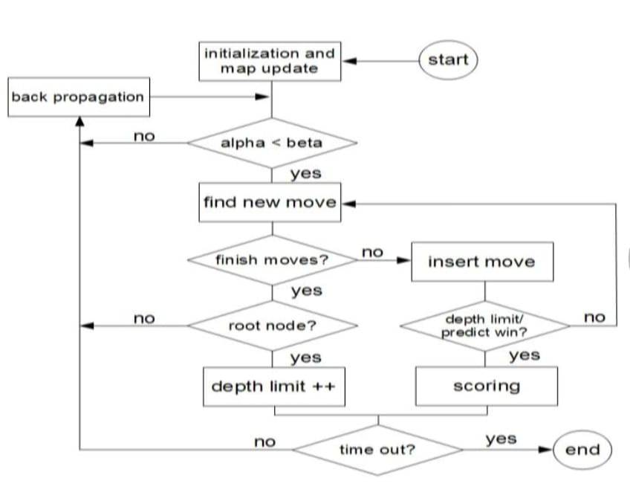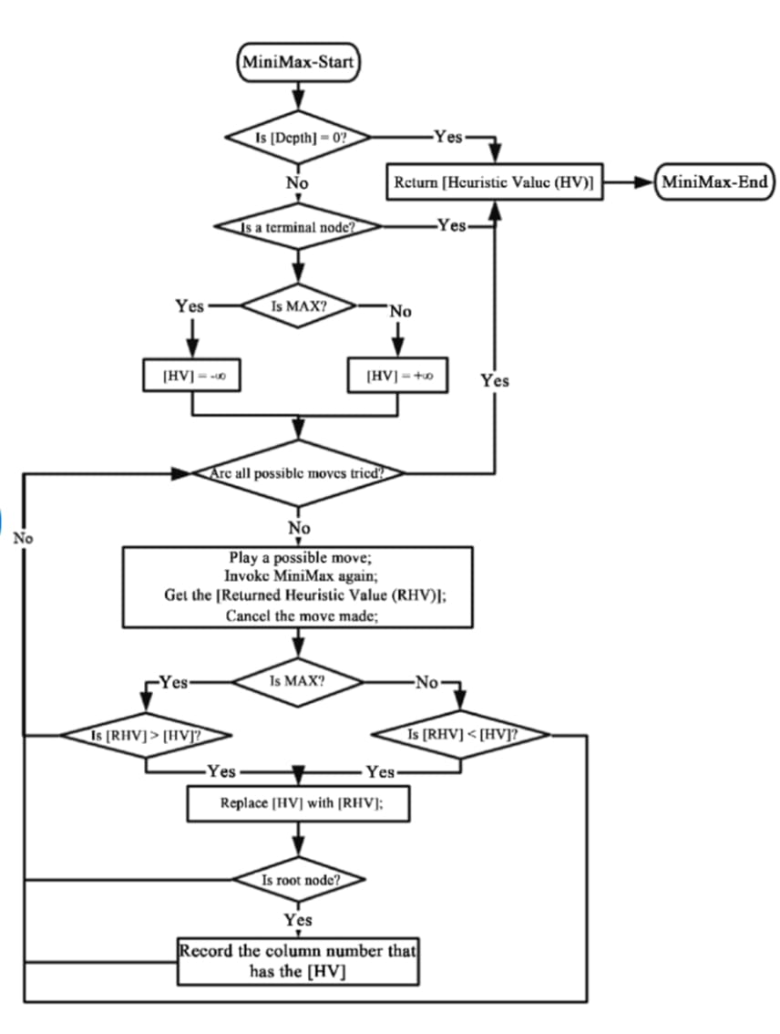:

Flow chart for game:

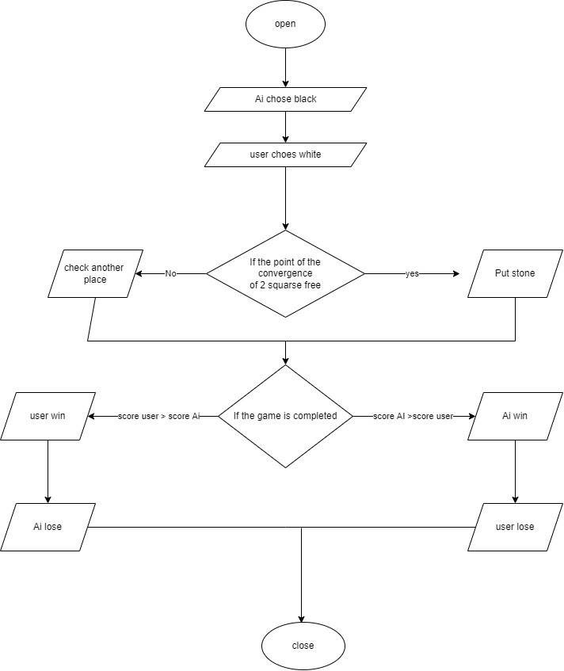

**Rules :**

The game of Go has few and simple laws, even children can learn quickly. However, the application of these laws is more complex.

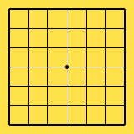

Go is played on a square board consisting of any number of crossing lines. The usual board sizes are 9x9, 13x13 or 19x19 lines, the latter being the official tournament size. To explain you the rules of the game we will use a 7x7 board since that will be more than sufficient for this purpose. You start the game with an empty board (but see also section handicap). The dark spot in the middle of the board is useful for orientation but also used as indicator (again see section handicap).

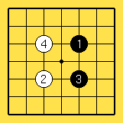

A Go move is played on the intersections of the lines. This is different from what you are used to from other games like chess and checkers. In the figure we show you the first four moves of an instruction game. The moves are numbered to indicate the order in which they were played. That's right, in Go the black player moves first! Another legal move, hard to display in a figure, is pass. When both players pass the game is finished.